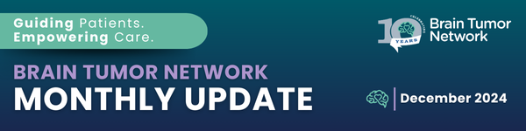


A Note of Thanks from Brain Tumor Network
As we approach the close of another year, our team reflects on the many moments of connection and collaboration that define our work. It is with profound gratitude that we thank you for trusting us to navigate this journey.
To our patients and caregivers: your resilience inspires us and reaffirms our mission to provide compassionate, patient-focused support. To the healthcare providers who collaborate with us: your dedication to enhancing the patient experience strengthens our shared impact. To the research community seeking better treatments and a cure: your work gives hope to families everywhere. To the nonprofit organizations supporting the community: your efforts to provide resources, raise awareness, and foster connections make a meaningful difference, and we are proud to stand alongside you in this shared mission.
As we celebrate the conclusion of BTN’s 10th anniversary, we are filled with hope for the decade ahead. This milestone reminds us of how far we have come since our founding in 2014, and it motivates us to build upon our impact. We're excited to further our efforts in educating about their right to a second opinion, the importance of molecular profiling, and demystifying the process of clinical trial enrollment.
Thank you for being part of our journey, for trusting us to be part of yours, and for joining us as we continue this critical work together.
With gratitude and hope,
Brain Tumor Network

 | Share Your Story to Inspire Others  Your experiences matter deeply—not only to us but to the many families who will navigate a similar journey. ​​​​If BTN’s services have made an impact on your life, we invite you to share your brain tumor navigation story.  - Your testimonial could help future patients and caregivers feel empowered, supported, and hopeful.

Make a Difference Through Giving  If you’ve been inspired by our mission and wish to support our work, we invite you to make an end-of-year contribution. Your gift helps us expand access to personalized navigation services and make a meaningful difference in the lives of those navigating a brain tumor. | 

Connect With Us:  
Copyright © 2024, All rights reserved.  Our mailing address is:  The Brain Tumor Network  816 A1A North  Suite 207  Ponte Vedra Beach, FL 32082 | 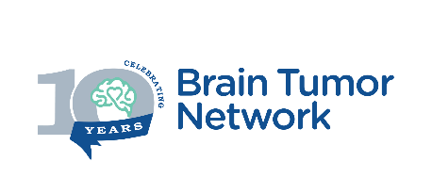
unsubscribe from all emails | update subscription preferences

